Practical Handgun Shooting Ancient and Modern

South Africans have for many years excelled in the shooting sports and are well-known as formidable opponents in the international competitions dedicated to the various shooting disciplines. A new generation is now emerging with ever younger competitors and enthusiasts from all walks of life across lines of gender, race and religion sharing the excitement and gratification of climbing the ladder of whatever log their shooting activity has chosen to follow. Sharp eyesight, lightning reflexes and athletic ability combined with the modern technological advances in firearms and the many components that are available to enhance the performance of those firearms continue to raise the bar in terms of competitive ability. Ironically however the basics still revert to principles of many decades ago when practical pistol or revolver shooting was in its infancy and when names long forgotten were not doing too shabbily. All of us have probably heard of or seen the incredible feats of the modern revolver genius Jerry Miculek who continues to amaze us with his feats but how many younger shooters know that Jerry is still trying to break some of the speed shooting records that were set by a man called Ed McGivern. This includes Ed’s feat of shooting, on September 13, 1932 — almost 83 years ago — five rounds from a double action revolver at a distance of 15 feet in 2/5 of a second, a group which incidentally could be covered by his hand – Jerry has come close and is still trying.

A common practice in years gone by was to engage in concealed carry competition using what was fondly called a “Fitz Special”. In South Africa in the ‘60’s these revolvers, which were mostly converted Colt 1917’s in .45Colt Caliber, were modified and used in informal competitions in the same manner as those carried and used by John Henry Fitzgerald or “Fitz” as he was commonly called until his death in 1944. In the popular TV series “Blue Bloods” the oldest member of this close knit police family hands down his “Fitz Special” to his Police Chief son. The weapons were modified by bobbing the hammer spur, shortening the barrel to two inches, rounding the butt, and removing the front half of the trigger guard. Reshaping the hammer and the butt allowed the gun to be drawn rapidly from a concealed cross draw holster with little risk of the weapon snagging on clothing. The halved trigger guard
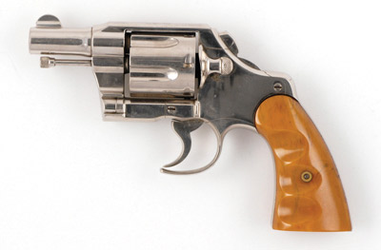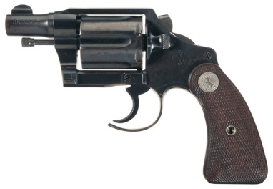
ensured virtually immediate access to the trigger and although it did of course ignore a few safety considerations they were fast! As a young plain-clothes policeman I carried one just like it as a back-up to my pip-squeak Walther PPK 7,65mm and shot it against other similar revolvers in the concealed FBI walk and draw competitions we held as often as we could afford to reload those powder and lead hungry .45 Long Colt cases.

New entrants to dedicated sports shooting are also at least hopefully aware of the contributions to their sport made by the late pistolero Jeff Cooper who after the revolver was dethroned as king of the circuits weaned us from our six-shooters to the old faithful 1911 .45 ACP. His credo of Vis, Celeritas, Diligentia (Power, Speed and Accuracy) still dominates not only in the continued use of the single action .45 ACP which is still regarded by many competition shooters as a state of the art weapon but also in the “power factor” still needed to qualify in many competitive shooting sports, while his “colour code” of the conditions of readiness are still universally practiced. Looking at the old 1911 on the left and the new competition fine-tuned clone on the right it seems that, in some cases, not that much has changed over the last hundred years after all!

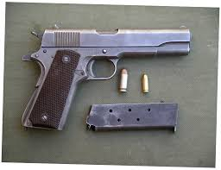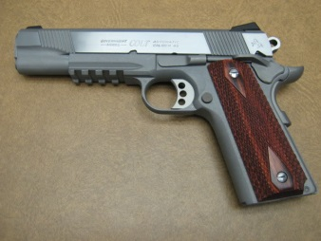

More importantly when it comes down to the wire, whether you use a five shot .38sp wheel-gun or an 18 round 9mmP semi-auto, keep the “practical” alive in practical handgun shooting competition and it may just one day save your life or the life of another innocent person.

Stay safe
Louis Steyn
May 2105

